Tejas Chopda

Assignment No: 01

Step 1: Go to Google extension store and search for Metamask extension.

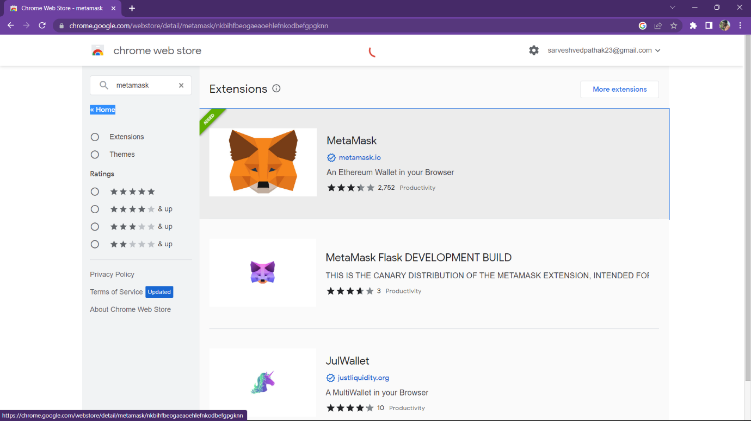

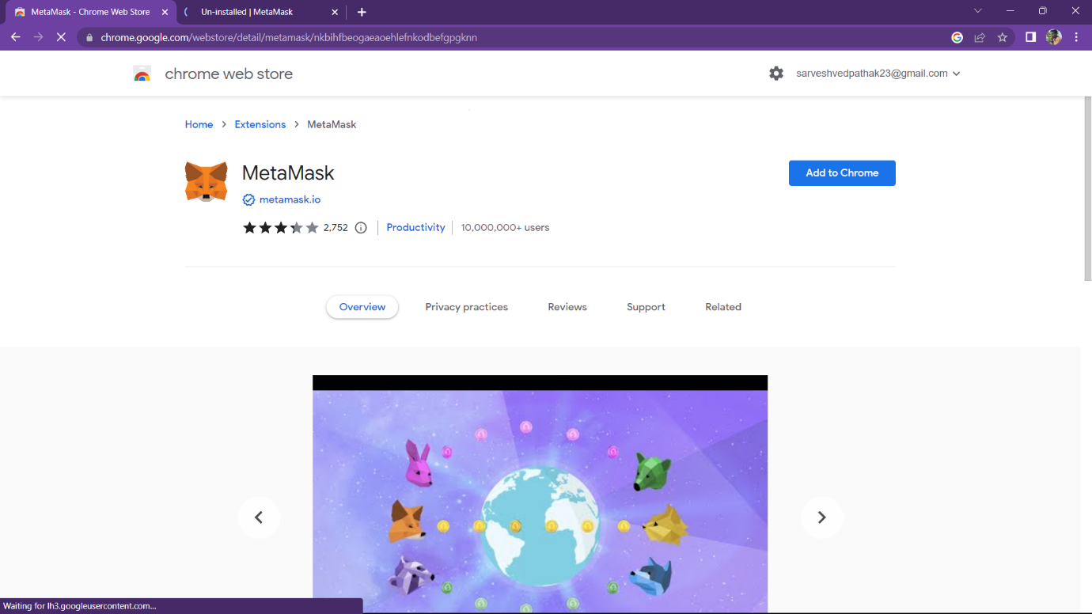

Step 2: click on add to chrome.

